Counterfactual Thinking: Appointing Blame

Former Student
Florida International University

Methods
Participants
One hundred and twenty six students from Florida International University were randomly selected to participate in our study. Of these 126 participants, 37% (n = 47) were male and 63% (n = 79) were female. Ages ranged from a minimum of 17 to a maximum of 58 with an average of 22.32 years (SD = 6.30). The sample population consisted of 68.3% Hispanic Americans (n = 86), 8.7% African Americans (n = 11), 19% Caucasians (n = 24), 1.6% Asians (n = 2), and 2.4% who did not specify their ethnicity (n = 3). See Table 1.
Table 1
Demographics – Study One
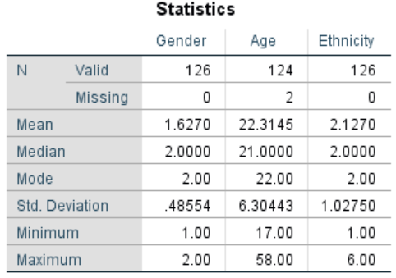
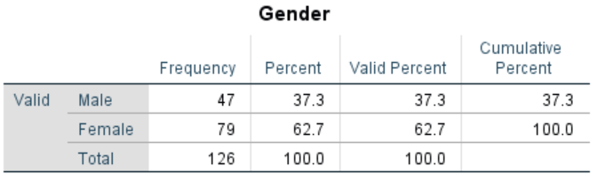
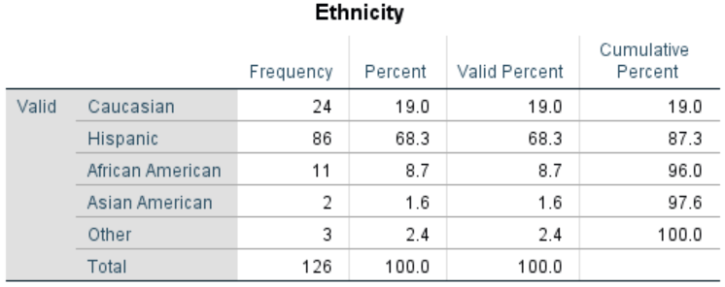
Materials and Procedure
In accordance with the standardized guidelines for informed consent, prospective participants were notified of the potential risks and benefits of participating in the study before being introduced to the research material. If the student verbally agreed to participate, he or she was given one of three different documents, each of which consisted of four parts or sections. In part one of the study, the participant read a short scenario concerning a paraplegic couple, Tina and Eugene, who requested a taxi for a night out with friends. Each of the three documents depicted the same initial situation with alternate conditions (changeable, unchangeable, or neutral).
In the changeable condition, the taxi driver arrived to pick up the couple, only to promptly decline their fare upon seeing that they were both paraplegic. Without enough time to call for another taxi, Tina and Eugene decided to take Tina’s car, which was handicap equipped. In order to reach their destination, they had to cross a bridge that had been weakened the night before due to a severe storm. The damaged bridge collapsed mere minutes before the couple reached it. Unable to see the missing portion of the bridge in the night, Tina and Eugene drove off the road, into the river below, and drowned. The taxi driver, who had left 15 minutes earlier, managed to make it safely across, before the collapse. In the unchangeable condition, the situation remained mostly the same with the exception that the taxi driver arrived at the bridge after it had collapsed and plummeted into the water as well. He managed to make it out of the car and swim to safety, but Tina and Eugene drowned. In the neutral condition, the taxi arrived to pick up the couple but promptly refused their fare as soon as he realized that they were both paraplegic. In this condition, the taxi driver did eventually agree to take Tina and Eugene to their destination downtown, albeit after much argument. Due to the recently collapsed bridge, the taxi driver drove his passengers and himself off the road and into the river below. He barely managed to make it out of the car before drowning. Tina and Eugene’s outcome remained the same.
After reading one of the scenarios described above, the participant continued on to the remainder of the study, which was composed of a series of open, partially open, and close-ended questions.
In part two, the student participating in the study was asked to procure as many ‘If Only’ statements as possible, meaning that they had to list all the factors they could think of that could have possibly changed the outcome of the event.
In part three, the participant was presented with a series of questions about their thoughts regarding the specific situation they read about. After reading each question, the participant was asked to record his or her response in a scale of one to nine. These questions included how avoidable they thought the accident was (1 = not at all avoidable, 9 = very avoidable), the causal role of the taxi driver in the couple’s death (1 = not at all causal, 9 = the most important cause), their thoughts on how much control the taxi driver had (1 = no control, 9 = complete control), the negligence of the taxi driver (1 = not at all negligent, 9 = completely negligent), how much money for damages the taxi driver was responsible for (1 = no money, 9 = as much as possible), the foreseeability of the couple’s death (1 = not at all foreseeable, 9 = completely foreseeable), and how much blame the taxi driver deserved for the event (1 = no blame at all, 9 = total blame). Remaining questions focused on a series of statements about the taxi drive, all rated on scales ranging from 1 (Strongly Disagree) to 9 (Strongly Agree). These statements included, “The taxi driver was reckless”, “the taxi driver was patient”, “The taxi driver was careful”, and “The taxi driver was hasty”. The last question of part three was a yes or no question that asked the participant whether the taxi driver agreed to drive the couple or not. This final question served as an attention check, which informed us if the participant was attentive to the study and allowed us to exclude potentially misrepresentative responses from our data.
Part four asked for the participant’s demographic information, including gender, age, ethnicity, their first language, and whether they were a student at Florida International University. Concluding the study, the participant was debriefed on his or her contribution to the study as well as our insights on counterfactual thinking and our main hypothesis.
Although we had several dependent variables, our primary focus involved the perceived blameworthiness of the taxi driver, the number of ‘If Only’ statements the participants could create, and the manipulation check regarding whether the driver agreed to take the couple. As such, these are the only three dependent variables that we analyzed.
Results
Using survey condition (changeable vs. unchangeable vs. neutral) as our independent variable and whether participants recalled whether the taxi driver picked up the paraplegic couple as the dependent variable, we ran a manipulation check in which we saw a significant effect, X²(2) = 93.95, p < .001. Participants in the changeable and unchangeable conditions correctly said the taxi did not pick up the couple (95.2% and 90.5%, respectively) while few participants in the neutral condition said the driver picked up the couple (4.8%). Cramer’s V, which is most appropriate for a 3 X 2 chi square, showed a large effect. This indicates that participants did pay attention to whether the taxi driver picked up the couple. See Table 2.
Table 2
Crosstabs and Chi Square – Study One
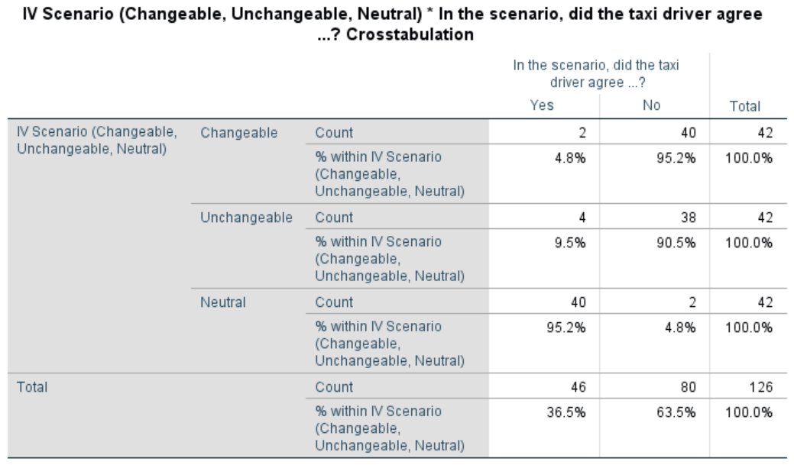
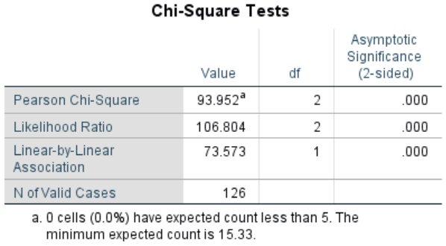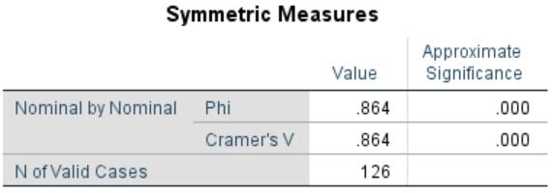

For our main analysis, our first One-Way ANOVA test revealed significant differences among our independent variable, the scenario conditions (changeable, unchangeable, or neutral) and our dependent variable, perceived blameworthiness of the taxi driver, F(2, 122) = 3.55, p = .032. A subsequent Tukey post hoc test supported our hypothesis by demonstrating that participants were more likely to blame the taxi driver in the changeable condition (M = 4.51, SD = 2.06) than in the unchangeable condition (M = 3.38, SD = 2.14).. However, there were no significant difference for perceived blame between the neutral condition (M = 4.36, SD = 2.11) and either the changeable or unchangeable conditions. These results indicate that in situations where the outcome is perceived as mutable (changeable), individuals are more likely to assign blame to the actor who could have acted differently (unchangeable). See Table 3.
Table 3
ANOVA Blame – Study One
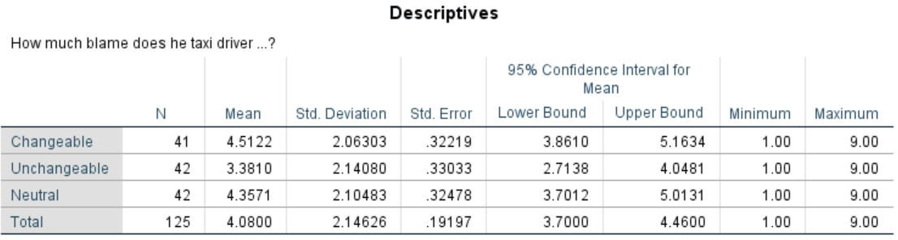
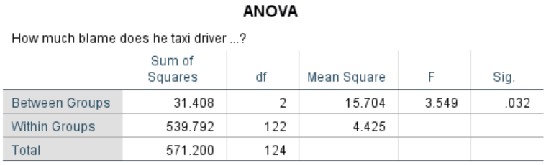
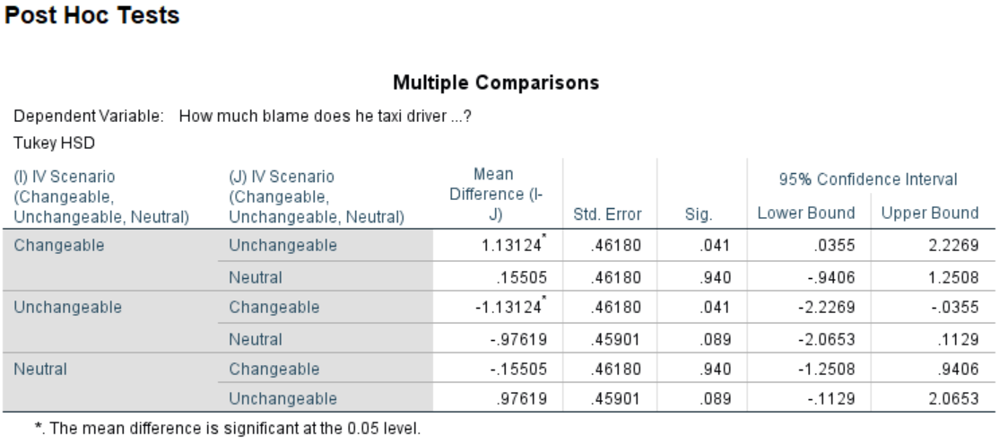
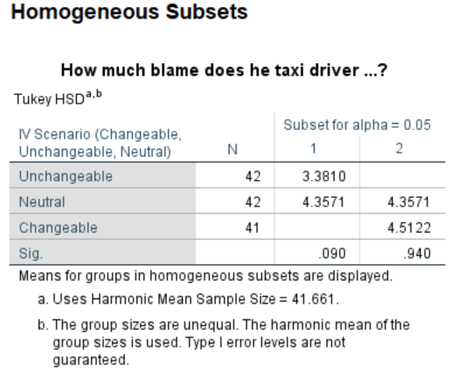
We were also interested in the number of ‘If Only’ statements generated for each condition. We ran a One-Way ANOVA test using the different conditions (changeable, unchangeable, or neutral) as our independent variable, and the number of counterfactuals produced as our dependent variable. The results revealed that the relationship between condition and number of ‘If Only’ statements produced was not significant, F(2, 123) = 1.79, p = .171. Our initial prediction that participants would develop more counterfactuals in the changeable condition was not supported since the number of counterfactuals generated in the changeable condition (M = 5.41, SD = 2.21), the unchangeable condition (M = 4.57, SD = 2.04), and the neutral condition (M = 4.88, SD = 1.85) did not differ. Since the p-value for the ANOVA test was not significant, there was no need to run post hoc tests. See Table 4.
Table 4
ANOVA Number of Counterfactuals – Study One
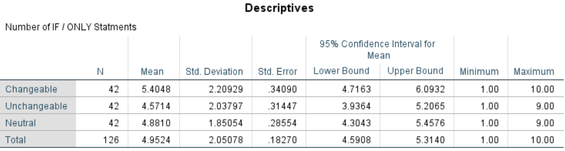
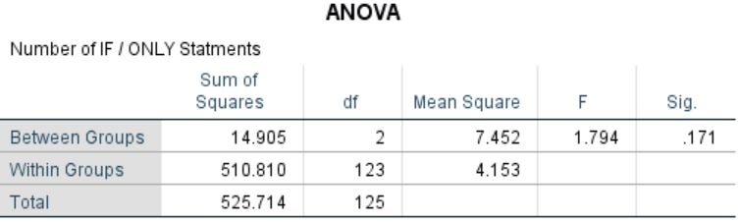
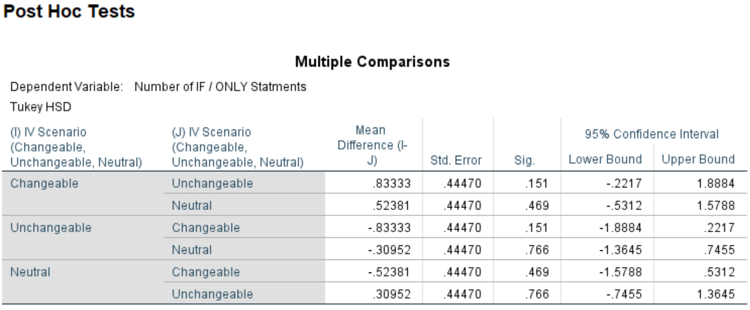
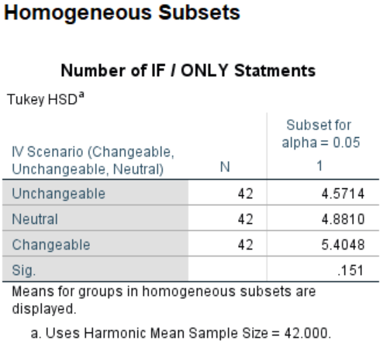
Finally, we ran an independent samples t-Test with the changeable and unchangeable conditions only and “How avoidable was the accident” as the dependent variable, which was significant, t(82) = 2.71, p < .01. Participants thought the accident was more avoidable in the changeable condition (M = 5.31, SD = 1.77) than in the unchangeable condition (M = 4.21, SD = 1.85). See Table 5.
Table 5
t-Test “Was the accident avoidable?” – Study One
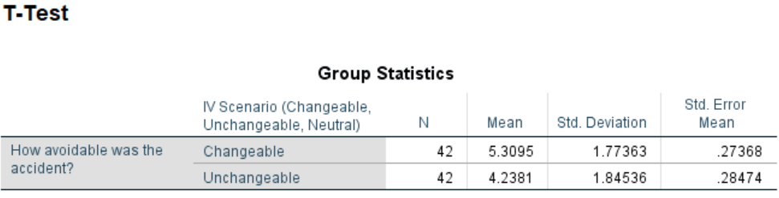
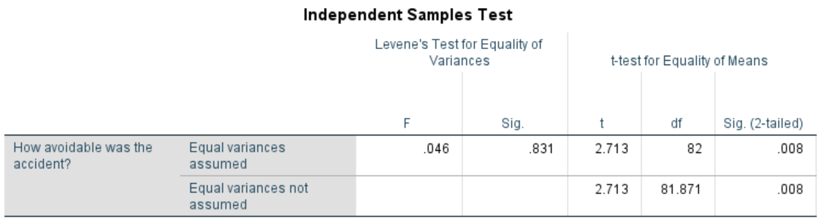
Discussion
We predicted that participants would place more blame on an actor whose behavior led to an undesirable outcome (death) when that actor could have acted differently primarily because these participants would generate more “If Only” counterfactual statements that would lead them to see the outcome could have been avoided. Conversely, we predicted that participants who read about an undesirable outcome that could not have been avoided would assign less blame to the actor and would think of fewer counterfactual “If Only” statements. Results partially supported these predictions, as we did find more blame for in the changeable condition compared to the unchangeable (though neither differed from the neutral condition), and they thought the accident was more avoidable in the changeable condition than in the unchangeable condition. However, the number of counterfactual statements that participants generated did not differ among our three conditions. It could be that participants were unfamiliar with the counterfactual task, which requires some deep thinking, though on a more unconscious level they could have seen the changeable condition as evidencing more elements of blame. This begs the question: what if participants were forced to think deeper? This is the focus of our second study.

